DATN-2377- Advanced Analytical Tools and Methods
Lab Work 1 for Chapter 10
(Total 100 points)

Perform the following exercises in your Jupyter notebook.

Submission Guidelines:
- Ensure that you complete this lab work using a Jupyter Notebook.
- Once the lab work is finished, convert the file into HTML format.
- Lastly, upload the HTML file to D2L for submission.

Chapter 10: Exercise 10-1 Create a linear regression
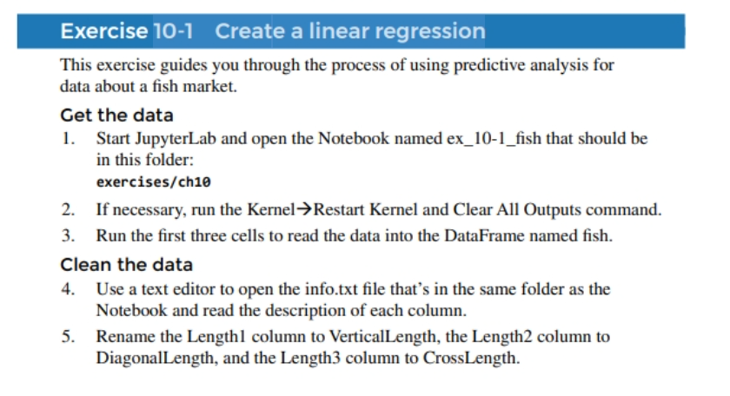

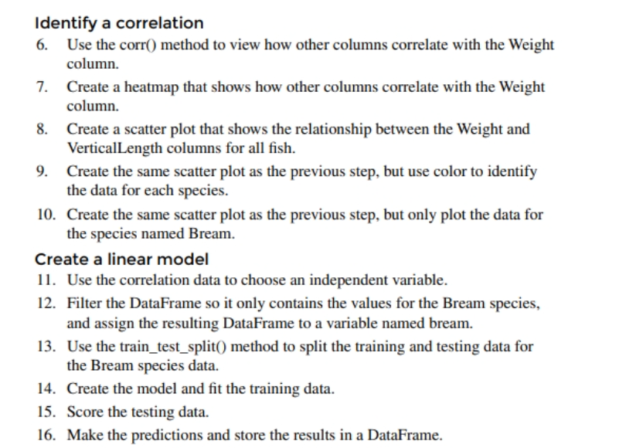

In summary, this project involves the analysis and visualization of a fish dataset to gain insights into the relationships between various fish attributes, potentially for research or educational purposes.
